***Brief API documentation***

Headers**:** 'Content-Type': 'application/json'

'X-Requested-With' : 'XMLHttpRequest'

**[POST]** api/auth/login (email, password)

Response:

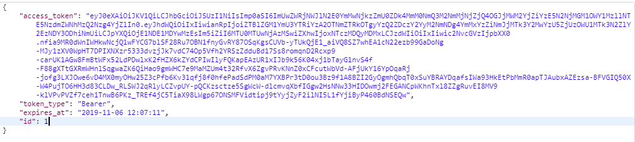

**[GET|HEAD]** api/auth/logout (Header: token)

Besides current header, must add authorization tag: 'Authorization': 'Bearer ' + token

Response:



**[POST]** api/auth/signup (name, email, password, password_confirmation, Header: token)

Response:



**[GET]** api/auth/user (Header : token)

Response:

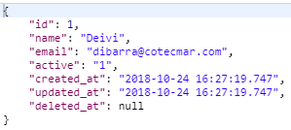

It returns this data of the logged user. It is to say it returns some data of any user with his active token.

**[POST]** api/auth/user_Id (id , Header : token)

Response:

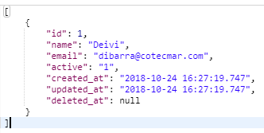

**[POST]** api/auth/Usuario_IdUser (iduser, Header : token)

Response:

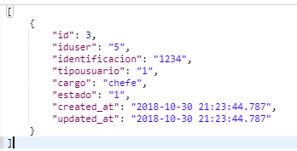

**[POST]** api/auth/SmUsuario ({iduser, identificacion, tipousuario, cargo}, Header: token)

Response:

**[GET]** api/auth/SmUsuario (Header: token)

Response: all the user with full data

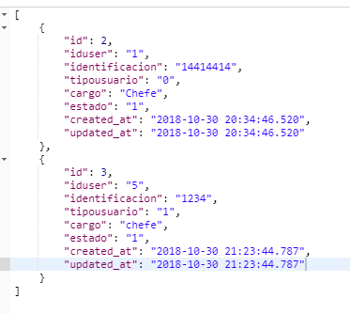

**[POST]** api/auth/SmInstalaciones (idusuario, descripcion, motivo_prestamo,fecha_solicitud, proyecto, gerencia, estado, fecha_salida , Header: token)

Response:

